Data Analytics with Power BI



**Tech Saksham**

Case Study Report

**“360 Degree Business Analysis of online Delivery Apps using Power BI”**

**“APC Mahalaxmi College for Women ”**

|  |  |
| --- | --- |
| **NM ID** | **NAME** |
| D7F880DB406BE7DBE9E49D04454100C9 | Priya.G |

**Trainer Name:** J.Arockia Jeyanthi

**Master Name:** Uma Maheswari

**ABSTRACT**

The purpose of this thesis is to build an online food ordering app. Our research also includes the “satisfaction of consumers by using online food services”. It will deal with consumer behavior & helps to analyze their perceptions & will also help us to understand consumer equilibrium.

**INDEX**

|  |  |  |
| --- | --- | --- |
| **Sr. No.** | **Table of Contents** | **Page No.** |
| 1 | Chapter 1: Introduction | 1 |
| 2 | Chapter 2: Services and Tools Required | 3 |
| 3 | Chapter 3: Project Architecture | 5 |
| 4 | Chapter 4: Modeling and Result | 7 |
| 5 | Conclusion | 10 |
| 6 | Future Scope | 11 |
| 7 | References | 12 |
| 8 | Links | 13 |

**CHAPTER 1**

**INTRODUCTION**

* 1. **Problem Statement**

Customer are having a hard time locating previous orders (they don’t exist at all or are too complex to locate)

How can I implement this feature and make it easily accessible ?

* 1. **Proposed Solution**

I included Order History in the bottom navigation for quick visibility and accessibility .

The user can view the status of an ongoing order from this section .

Clicking on any of the previous orders , the user can view details of the order, reorder easily and also post complaints

* 1. **Feature**

Food ordering: Allowing the users to order their food on-the-go from two different restaurants .

No minimum order: The customer does not have to a minimum amount to order from a restaurant .

Table Booking: Enables the users to book a table at the listed restaurant their choice with just a few taps and the wait time at the restaurant is eliminated .

Explore Places: Offering the discovery and guide to the user for exploring nearby restaurants with pictures , reviews and map locations .

* 1. **Advantages**

Opened 24/7

Save time and money

Reduce costs

Hits the target market

Online delivery mechanism

Food can be ordered from multiple sources

Paper wastage is reduced

* 1. **Scope**

Users are diverting towards healthy food options and the peollple who stay alone want more affordable home-cooked food options as their food choice .

Users want to stay fit and also track their nutritional intake .

Users want more transparency between themselves and the restaurants in terms of knowing their cooking methods/kitchen cleanliness and hygiene and the quality of ingredients being used for food preparation. Difficulty in cooking food at home mostly because of lack of time.

**CHAPTER 2**

**SERVICES AND TOOLS REQUIRED**

**2.1 Services Used**

Data Integration Services: Services for data integration are crucial for collecting and consolidating data from various sources transactional databases, customer feedback platforms, delivery tracking systems and market research databases .Tools like Microsoft Power automate, Azure Data Factory and third party Services like zapier can be used for seamless data integration .

Data Warehousing: Storing and organizing data efficiently is essential for performing analytics effectively. Data Warehousing Services Azure synapse Analytics and Amazon Red shift can be used to store large volume of structured and unstructured data for analysis .

Cloud storage: Cloud storage solution like Azure Blob storage and Amazon S3 can be used to store raw data, intermediate data and processed dataset securely, making it accessible for analysis by Power BI and other tools.

Machine Learning Services: Azure Machine Learning or AWS Sage Maker can be used to build predictive models based on historical data.

**2.2 Tools and Software used**

**Tools**:

* **PowerBI**: The main tool for this project is PowerBI, which will be used to create interactive dashboards for real-time data visualization.
* **Power Query**: This is a data connection technology that enables you to discover, connect, combine, and refine data across a wide variety of sources.

**Software Requirements**:

* **PowerBI Desktop**: This is a Windows application that you can use to create reports and publish them to PowerBI.
* **PowerBI Service**: This is an online SaaS (Software as a Service) service that you use to publish reports, create new dashboards, and share insights.
* **PowerBI Mobile**: This is a mobile application that you can use to access your reports and dashboards on the go.

**CHAPTER 3**

**PROJECT ARCHITECTURE**

**3.1 Architecture**



Here’s a high-level architecture for the project:

Front-end web or mobile application : This is the interface customers use to generate menus , browse menus, place orders and delivery status .

Backend server are services: This component handles requests from the front end , communicates with the database, and coordinates with delivery partners .

Database : This stores information about menus, orders, customers and delivery partners.

API Gateway: This is responsible for request routing ,composition and protocol translation among other things between an application and the set of micro services .

Messaging Queue: An asynchronous communication between systems that allows multiple systems to send and receive messages reliably and efficiently without needing to be constantly connected. Notification Service: To send notifications to users, typically through email or push notifications. Tracking Engine: This will constantly watch for changes in the DB, update the elastic search index, and notify the messaging queue.

**CHAPTER 4**

**MODELING AND RESULT**

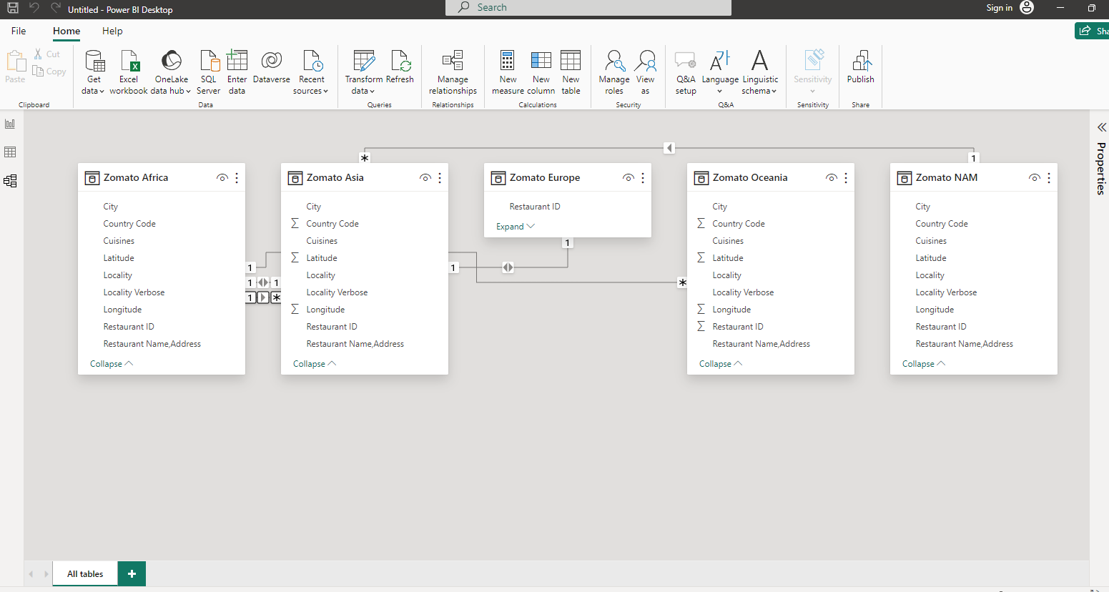

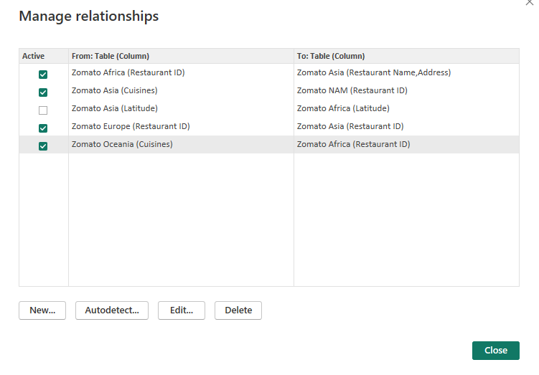

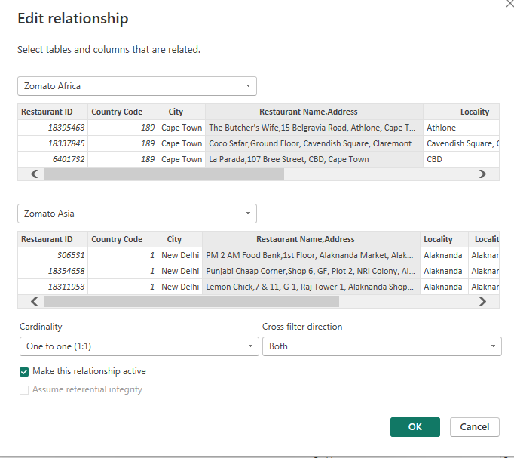

**Dashboard**

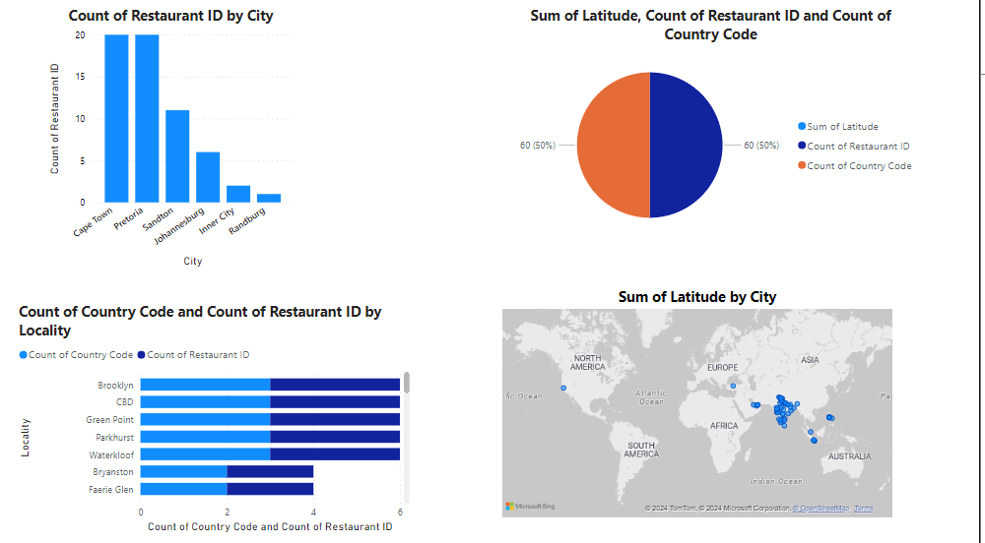

**CONCLUSION**

.Nowadays the traditional way of going to a restaurant and eating has reduced considerable . It’s a new age where technology dominates human life . With the software and technological devices , exceptions are reduced and even terminated . Also people prefer easy , quick and save access to everything. This project is designed to meet the requirements of a restaurant.

The Online Food Ordering System provides a simple way to store details of the customer , Food items available and to generate the bill.

**FUTURE SCOPE**

The Online Food Delivery market in India is projected to reach a revenue of US$43.78bn in 2024.

In global comparison, in China is expected to generate the highest revenue in the Online Food Delivery market, with US$448.90bn in 2024.

The average revenue per user (ARPU) in the Grocery Delivery market in India is projected to amount to US$183.40 in 2024.

In the Meal Delivery market in India, the number of users is expected to reach 346.6m users by 2028.

The user penetration in this market will be at 18.4% in 2024.

India’s online food delivery market is experiencing rapid growth due to the increasing demand for convenience and the wide range of cuisines available.

**REFERENCES**

<https://dialnet.unirioja.es/descarga/articulo/8994373.pdf>

**LINK**